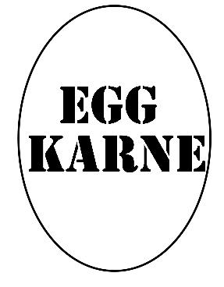

All prices below includes tax
Served All Day
Longanisa Sausage, Cage Free Egg, Cheese, Brioche^{1 *} - $7.00
Chorizo, Cage Free Egg, Cheese, Brioche^{1 *} - $7.00
Adobo Pork Belly, Cage Free Egg, Cheese, Brioche^{1 *} - $7.50
Sage Sausage, Cage Free Egg, Cheese, Brioche^{2 *} - $7.00
Applewood Bacon, Cage Free Egg, Cheese, Brioche^{2 *} - $7.00
Chicken Sausage, Cage Free Egg, Cheese, Brioche^{2 *} - $7.00
Cage Free Egg, Cheese, Brioche^{3 *} - $6.00

Served after 10:30 AM

Sharing Snacks
Lumpia Filipino Vegetable Eggrolls (3) - $5.50
Lumpia Filipino Beef or Chicken Eggrolls (5) - $6.75
Arroz Caldo Fried Balls with Jalapeno Fish Sauce - $6.75
Spam Fries - $6.00
Adobo Pork Belly Loaded French Fries- $8.50
Fresh Cut Fries - $2.50 (s) $4.50 (l)
Crispy Chicken Tenders - $5.75
Chicken Wings (with Karne Sauce) - $10.00
Sandwiches and Misc
All natural 100% Angus Cheese Burger^{2 *} - $8.50
50/50 Wagyu / Angus Cheese Burger^{2 *} - $12.00
Veggie Burger - $6.75
¼ Pound All Beef Hot Dog or Bratwurst with Sauerkraut - $5.75
Chicken, Tuna, or Egg Salad Sandwich - $6.25
House Salad (protein additional) - $6.75
Homemade Chili - $6.00
Add chips to any sandwich - $1.00
Local Favorites
Grilled Cheese Sandwich with chips - $5.00
Weekly Sandwich Special with chips - $6.00
Dessert
Turon (Plantain and Jackfruit) served over vanilla ice cream - $5.50
¹ – Karne Sauce - Filipino BBQ Sauce
² – Karne Sauce with Siracha / Mayo / Filipino Ketchup
³ – Aioli Sauce – Mayonnaise base Sauce
* See Consumer Advisory Warning

